ALR User Documentation
7/28/2022

Table of Contents
ALR User Documentation 1
Introduction 5
Important Things of Note 5
Connections 5
ALR Postgres Database 5
PROD 5
DEV 5
Ad-Hoc S3 Bucket 5
PROD (2epv-lo174-cs-data-input-s3) 5
DEV (2epv-lo174-cs-data-input-dev) 6
Archive S3 Bucket 6
PROD (2epv-lo174-archive-prod-infrequentaccess-s3) 6
DEV (2epv-lo174-cs-data-input-archive-s3) 6
Fetch Processes 6
Daily Process 6
Fetch/Validations/LSE 6
Automatic Switching 6
Monthly Readiness 7
Backdated Process 7
Fetch/Validations/LSE 7
Automatic Switching 7
Monthly Readiness 8
Reprocessing 8
INTONLY Studies 8
ALR Design 8
Tables Populated by the Fetch Processes 9
fetch_results/premise_usage 9
error 11
active_premise 12
Tables Populated by the Ad-Hoc Process 13
population/seasontou/study/study_premise/systempeak 13
variable 13
monthly_stratum 14
archive 15
study_to_reprocess 15
ETL Tables 15
adhoc_process_control/ etl_adhoc_process_control 15
etl_adhoc_log 15
etl_log/etl_backdated 15
etl_monthly_readiness 15
Primary Keys 15
Virtual Delete Logic 16
Referential Integrity 16
Foreign Keys 16
Ad-Hoc Design 17
Tables 17
Files 17
Folder/Ingestion 17
Input Files 18
Table Files 18
File Request File 18
Trigger File 18
Naming Convention 19
Expected File Structure 19
Inserts 20
Updates 20
Deletions 20
File Requests 20
Trigger 20
File Request Output 21
Table Ad Hoc Request Example 21
File Process Order 21
Archive 22
Reporting 22
Long-term Archive Process 23
S3 Long-term Archive 23
Continuous Archival Retention Policy 24
End-Dated Archival Retention Policy 25
Archival Exemption 25
run_arch_flg 25
Archive Removal 26

Introduction
This application is built as a tool so support the regulatory team in conducting load research and analysis. Leveraging the benefits of an AWS platform, the application was built in modules and can (in most cases) be configured to meet the regulatory team’s business requirements.

Important Things of Note
- The company feature should not contain any special characters. Example: FPL-C should not be used, use FPLC instead.
- Commas should not be used in any studyid or studydescription. If any env/ctl ends up with unwanted quotes, it is due to a comma being used in an ALR feature.
- The company identifier with a dash (example: FPLC-) should be the prefix to any studies associated with that company. Example: FPLC-RS20
- Studyid should take the form [company]-[study] with no special characters in [company] or [study]. Example: GE-LP(T) should not be used. Instead use GE-LPT

Connections

ALR Postgres Database

PROD
Host | aws-fpv-lo174-clrp-cluster-0a76fdf35965-rds.cluster-cgqep0gwcrlg.us-east-1.rds.amazonaws.com
Port | 5605
Database | clrp
User | clr_ro_user

DEV
Host | aws-fnv-lo174-clr-cluster01-instance01-rds.c4ucntsmqjsv.us-east-1.rds.amazonaws.com
Port | 5605
Database | clrd
User | clr_ro_user

Ad-Hoc S3 Bucket

PROD (2epv-lo174-cs-data-input-s3)
Host | sftp-int.nee.com
Port | 22
Username | edp-lr-lo174-dev
Authentication | aws-sftp-key.ppk

DEV (2epv-lo174-cs-data-input-dev)
Host | sftp-int.nee.com
Port | 22
Username | edp-lr-lo174-sftp-lo174-dev
Authentication | aws-sftp-key.ppk

Archive S3 Bucket

PROD (2epv-lo174-archive-prod-infrequentaccess-s3)
Host | sftp-int.nee.com
Port | 22
Username | edp-lr-archive-IA-lo174-prod
Authentication | aws-sftp-key.ppk

DEV (2epv-lo174-cs-data-input-archive-s3)
Host | sftp-int.nee.com
Port | 22
Username | edp-lr-archive-lo174-dev
Authentication | aws-sftp-key.ppk

GitHub for Json SQL codes
https://github.com/NextEraEnergy/lo174-csdat-load_research/tree/dev/Prod/loadresearch/sqls
https://github.com/NextEraEnergy/lo174-csdat-load_research/tree/master

Fetch Processes
The daily process is scheduled to automatically run every day at 18:30 UTC (1:30 PM EST/2:30 PM EDT).
The backdated and reprocess processes are scheduled to automatically run every day at 13:00 UTC (8 AM EST/9:00 AM EDT).

Daily Process

Fetch/Validations/LSE
Interval and master data for study premises billed 8 days prior to the current date is fetched for active studies from source tables. Missing intervals are interpolated based on the interpolation requirements, and the data is aggregated to the channel level to be passed through to validations. The validations process runs a series of checks at both the channel level and premise/account/bill level, and then writes the data to the ALR database tables fetch_results, premise_usage, and error. LSE files for the data are also created and written to their output folder.

Automatic Switching
If the current date is on or after the SWITCHDAYOFMONTH (a variable stored in the variables table), the automatic switching process occurs. Automatic switching runs a series of checks to determine which studypoints should be active for a study for the prior relative month. The results are written to the active_premise table in ALR, and monthly errors are logged to the error table. Ratecode and “INTONLY” type studies are automatically set as active (current_flg = TRUE) for being used in their study, errors are still written though.
For example, if SWITCHDAYOFMONTH is set to 21, on the 21st day of December automatic switching occurs for the rltv_mo of November. (This process may occur after the SWITCHDAYOFMONTH if there are no bills to fetch on that day. In this case automatic switching will occur on the first day a regular data fetch is completed.)

Monthly Readiness
A monthly readiness check runs at the end of the daily process. This checks for new study/rltv_mo combinations in the active_premise table (i.e. studies that just underwent automatic switching), and then checks whether the accompanying data for the study and/or rltv_mo exists in monthlystratum and systempeak. Based on this information, an email is sent to subscribers via AWS Simple Notification Service (SNS) listing studies/rltv_mos that are ready to be processed or studies/rltv_mos that are not ready in monthlystratum or rltv_mos that are not ready in systempeak. Studies/rltv_mos that are ready are also logged in the etl_monthly_readiness table so duplicate SNS messages are not sent.
An SNS email is sent only when new studies/rltv_mos are ready, which would occur either after automatic switching occurs or after systempeak or monthlystratum are updated via the ad-hoc process (monthlystratum in this case would be updated indirectly via the corresponding ratecodes in the population table).

Backdated Process

Fetch/Validations/LSE
Backdated data is subject to a process similar to the daily process, except that data is fetched by relative month instead of a single cycle day. Interval data is fetched for the given backdated studies one relative month at a time.

Automatic Switching
Automatic switching occurs at the end of the validation process for each rltv_mo, unless the backdated fetch is caught up to present, in which case automatic switching will be performed by the daily process later. For example, if a backdated fetch is performed on December 15, the backdated process will not handle automatic switching for the rltv_mo of November, since this will be completed later by the daily process on December 21, assuming SWITCHDAYOFMONTH is set to 21.

Monthly Readiness
The same monthly readiness check as that of the daily process is called after each rltv_mo is fetched/validated. This means that subscribers will receive an email via SNS upon the completion of each rltv_mo in a backdated fetch.

Reprocessing
Due to interactions with the different modules, the only reprocessing functionality offered is by study/rltv_mo. This is due to one premise potentially impacting the data of another premise (namely, whether or not a studypoint is active in active_premise, as determined by automatic switching).
A reprocessed fetch is treated as a special case of a backdated fetch, following the same procedures outlined above. The validations process, however, first removes the necessary data from ALR by study and rltv_mo to avoid duplicate errors when the data is written to the tables again. Note that BILLONLY rows in fetch_results are updated by reprocessing if they are still needed but cannot be deleted in the rare scenario that a premise correctly changes away from net-metering when reprocessed.

INTONLY Studies
Premise studies designated as “INTONLY” in the study name (ex.: “GE-INTONLY2”) should have no alternates or decimal studypoints and can be used in the daily or backdated processes. No automatic switching occurs for these studies, and the current_flg in active_premise is always TRUE, similar to premises in rate studies.

ALR Design
ALR is a PostgreSQL database. The CLR schema is used in Prod and Dev/Test. Dev/Test also has the public schema that can be used for testing processes that require more data manipulation.
The following tables exist in the clr schema:

Tables Populated by the Fetch Processes
- fetch_results
- premise_usage
- error
- active_premise

Tables Populated by the Ad-Hoc Process
- population
- seasontou
- study
- study_premise
- systempeak
- variable
- monthlystratum
- archive

ETL Tables used to manage the ALR system
- adhoc_process_control
- etl_adhoc_log
- etl_adhoc_process_control
- etl_backdated
- etl_log
- etl_monthly_readiness
- study_to_reprocess

Tables Populated by the Fetch Processes
These tables are handled exclusively by the ALR system.l

fetch_results/premise_usage
These tables collectively display the results of the fetch and validation processes.
- The fetch_results table displays monthly data at the meter and channel level.
- The premise_usage table displays monthly data aggregated to the premise/account/bill level.
Premises are matched to studies in both fetch_results and premise_usage. For rate studies, integer studypoints are created for each premise/study combination.
All channels in fetch_results are notated numerically as mapped below, including GE channels, which are translated to FPL notations.
- For mass market:
Channel | Description | GE Equivalent
1 | Delivered (non-net-meter) | skwh
2 | Delivered (non-net-meter & net-meter) | kwh
4 | Received (net-meter) | gkwh
9 | Totalized (Delivered – Received)
- For Power Billing:
Channel | Description
1,4,7,10… | Delivered
2,5,8,11… | Received
109 | Totalized Power Billing (non-net-meter)
119 | Totalized Power Billing (net-meter)
Additionally, if meter data is unavailable for a premise, the channel field is set to ‘-1’, since channel is part of a primary key and cannot be null.

study_channel_flg Logic
fetch_results includes all channels that were fetched even if those channels are not used for the creation of env/ctl files. Whether a channel is passed to the env/ctl files is controlled by the field study_channel_flg, which takes Boolean (True/False) values.
For example, if a premise with net-metering is included as a studypoint in a non-pure premise study, channels 2, 4, and 9 would all be included in fetch_results for the study. However, the study_channel_flg would only be True for channel 9.
Similarly, for a powerbilling premise, the study_channel_flg would be False for all the component channels, but true for channel 109.
For a channel specific net-metering study, the study_channel_flg would be True for only the specified channel.
For a PURE study, the study_channel_flg would be True only for non-net meter premises.

Net Meter Logic
Net meter status is determined by premise/bill combinations. If a premise was net meter at any point during a given bill, that premise/bill combination is recorded as net meter. Below are the special cases that the ALR system handles for net meter premises.

In cases where a meter switches to net metering, or back to non-net metering, in the middle of a bill, the non-net-meter channel (i.e. channel 1) is also fetched, even if it wouldn’t otherwise be included in a study. This is because it still needs to be included in the aggregation at the premise/account/bill level for premise_usage in order to accurately perform bill comparisons. But since a studyid is required for a channel to be included in fetch_results, a faux study, BILLONLY, is matched to the channel 1.
Note that in all cases, the study_channel_flg is False for BILLONLY channels, meaning that these channels are never used in control or environment files.

In cases where a net meter exists but is manually read, the premise will show in the ALR database under NET9 studies. These manually read premises will not be in NET2 or NET4 studies and will not be included in environment and control files

For FPL-NW it is possible for a net meter billed customer to only have intervals for channel 2. In this case the premise will only show in NET2 studies and will not show in NET4 or NET9 studies.

To get a count of total net meter premises for a given relative month, a count of unique premises from all NET2 and NET9 premises should be used.

It is possible for premises to have net-meter channels but not be billed for net-metering. In this case, the netmeter flag in fetch_results would be False for all channels of the premise even though channels 2, 4, and 9 exist. However, in this case, only channel 2 (delivered) is treated as the active channel; the study_channel_flg for channel 2 would be True while the study_channel_flg for channels 4 and 9 would be False. Similarly, only channel 2 would be aggregated to the premise/account/bill level in premise_usage.

error
- The error table displays monthly data at the premise level.
Errors are logged both daily by the validations process and monthly by the automatic switching process.
The following errors are generated by the validations process:
Error Code | Description
SPI | An error is written if more than one distinct SPI value is found in the intervals. This is also flagged by the spi_flg field in fetch_results.
SPILENGTH | An error is written if the SPI for an interval is longer than 60 minutes.
NODATA | An error is written if no meter data could be fetched, but a bill was fetched.
BADINTV | An error is written if the percent of intervals missing after interpolation is attempted (badintvper in premise_usage) exceeds the threshold given by DRO in the variable table. Automatic switching occurs, if applicable, when this feature exceeds INTDATASECOND from the variable table.
DIFFBILLCOMP | An error is written if the difference between the cut usage and the billed usage (kwh and billkwh in premise_usage, respectively) is greater than the threshold given by BILLCOMP in the variable table.
NULLBILL | An error is written if billed usage (billkwh in premise_usage) is null or 0. Bill comparisons cannot be made if billed usage is 0, since the operand would be undefined.
INCOMPINTVS | An error is written if the maximum meterstop_dt for all channels fetched for a bill is less than the bill’s billstop. This indicates that there should be at least one more channel to cover the rest of the bill, but such intervals could not be fetched.
AUMONTH | An error is written if the number of months available to calculate average monthly usage is less than the threshold set by AUMONTH in the variable table.
METERCHANGE | An error is written if a meter stopped or started within the duration of the bill, based on the values of meterstart_dt, metersop_dt, billstart, and billstop.
PURESTUDY | An error is written if a premise is matched to a “PURE” study in fetch_results but contains at least one net-meter channel (as marked by the netmeter flag).
INFORMATIONAL | An error is written for each master data change in any of the following fields for a premise: customer, accountid, account_status. Premises are compared to any prior data for the premise existing in the ALR database, as well as any new data.
DUPROWS | An error is written if the data for Gulf has 2 rows for the same netmeter status in the same bill. This happens because of a backdated change in CAMS which ALR cannot solve for without creating duplicate interval rows. This is a very rare error and should be monitored for frequency.

The following errors are generated by the automatic switching process:
Error Code | Description
RATECODE | An error is written if a premise’s ratecode is not one of the ratecodes specified by the study to which it is matched.
STRATUM | An error is written if a premise’s avgmonthlykwh is outside of the kwh limits of the stratum defined for the studypoint. Stratum kwh upper limits are defined by the stratumkwh field of study.
BILLDATA | An error is written if no bill was fetched for a studypoint for the given rltv_mo.

active_premise
The active_premise table displays the results of automatic switching, showing monthly data at the premise level. That is to say, if a rltv_mo for a premise has two bills, active_premise combines the bills so there is one row for each rltv_mo/premise/studyid combination.
All fetched premises are included in active_premise. For premise studies, this includes all active studypoints as well as failed studypoints and unused alternate studypoints. All premises for rate studies are also included.

current_flg
The current_flg shows whether a studypoint is active, as determined by automatic switching, with True meaning active and False meaning inactive. For each integer studypoint in a premise study, the current_flg should only be True for one point—either the integer studypoint itself or one of its decimal alternates.
Automatic switching rules dictate that the last month’s active point be tried as the current month’s active point first (or the integer studypoint if switching has not occurred yet for the study). If this fails, sequential alternates are tried in successive order until a new active point is found, looping back to the original integer studypoint if necessary.
For premises in ratecode and INTONLY studies, no switching occurs, and the current_flg is always True.

prior_alt
The prior_alt flag shows which studypoint was active in the prior rltv_mo if a switch occurred. For example, if last month studypoint 1.0 was active but studypoint 1.0002 is the active studypoint this month, the value of the prior_alt field for studypoint 1.0002 would be 1.0 for the rltv_mo where the switch occurred. If studypoint 2.0 was active last month and is still active this month, the value of prior_alt field for studypoint 2.0 would be null.
Counting the prior_alt field shows the number of times that a switch occurred.

Tables Populated by the Ad-Hoc Process

population/seasontou/study/study_premise/systempeak
These tables are expected to be maintained by the regulatory team via the ad-hoc process.

variable
The variable table allows for the regulatory team to control certain specifications of the system. It is also updatable via the ad-hoc process.
The following table lists variables and a description of their functions/purposes:
Variable Name | Value Type | Description
STDYDATARETAIN | Integer | The number of months for which records related to an end-dated study are retained in ALR. Records related to these studies will be archived after this time.
DATARETAIN | Integer | This feature is not currently used.
AUMONTH | Integer | The number of months used to calculate a premise’s average monthly usage
BILLCOMP | Decimal  (between 0 and 1) | The percent threshold for writing errors for the difference between billed kwh and cut kwh
CALENDARBILL | Premise list | Handles power billing premises that bill on a calendar month. Actual bill dates do not match in CIS, so a premise list is used.
SUNDAYBILL | Premise list | Handles power billing premises that bill Sunday to Sunday. Actual bill dates do not match in CIS, so a premise list is used.
SWITCHDAYOFMONTH | Integer | The day of the month on which automatic switching will occur for the prior cycle month. If this day is not a cycle day, automatic switching will occur on the first day thereafter.
AGG | Text | These fields are used for building control and environment files.
REP | Text
DRO | Text
WRI | Text
QUA | Text
MIN | Text
ICS | Text
ASS | Text
PRO | Text
BIL_330 | Text
TYP | Text
SOU | Text
BIL_340 | Text
DRO | Percentage | The threshold for which a BADINTV error is written. If the percent of intervals missing after interpolation is attempted (badintvper in premise_usage) exceeds this value, an error is written.
INTDATASECOND | Decimal  (between 0 and 1) | The upper bound percent of missing intervals for which interpolation is attempted. If the percent of missing intervals exceeds this value, interpolation will not be attempted and the premise will be switched if applicable.
INTDATAFIRST | Decimal  (between 0 and 1) | The lower bound percent of missing intervals for which interpolation is attempted.
STANDBY | Premise list | Handles power billing premises that use received channels (2,5,8...) instead of delivered channels (1,4,7...) as delivered kwh for billing comparison. Uses a premise list.

monthly_stratum
The monthly_stratum table is populated automatically by the system whenever ad-hoc changes are made to either the population table or the study table. The appropriate records of monthly_stratum are updated according to the ratecodes updated in study and/or the sales/customers updated in population.
The billedkwh and customers fields of monthly_stratum represent the totals for the rateclass multiplied by the weight for the given stratum.
The rateclass_billedkwh and rateclass_customers represent the totals for the rateclass before weights are multiplied. A rateclass report can be generated by simply filtering for unique values of rateclass_billedkwh and rateclass_customers for each study/rltv_mo, using a query such as:
select distinct
studyid,
rltv_mo,
rateclass_billedkwh,
rateclass_customers
from public.monthlystratum
order by rltv_mo, studyid

archive
The archive table records any meaningful updates performed by the ad-hoc process. If data in any field other than the updated_dt or updated_by changes values, all fields from before and after the change are recorded and stored in .json configurations as rec_before_update and rec_after_update, respectively. This includes the archival of virtual deletes via changes to the deleted_flg.

study_to_reprocess
The study_to_reprocess table controls which studies are run for reprocessing. Data is fetched for the study/rltv_mo combinations listed in the table, and existing data for those combinations is removed before it is validated and re-written to ALR, with a validation_run_date signaling completion.

ETL Tables

adhoc_process_control/ etl_adhoc_process_control
These tables are used by the system to handle ad-hoc requests and should not be altered by users.

etl_adhoc_log
Successful ad-hoc requests are logged to etl_adhoc_log. Table requests list a table_name and a number_of_records that were updated. File requests record the number of files transferred in the number_of_records field.

etl_log/etl_backdated
The etl_log and etl_backdated tables track the status of the daily process and backdated process respectively for each study.

etl_monthly_readiness
The etl_monthly_readiness table logs study/rltv_mo combinations that are ready for processing according to the monthly readiness check. The records of this table should correspond to those detailed in the SNS emails sent.

Primary Keys
Table | Primary Key
active_premise | studyid, rltv_mo, premiseid
error | studyid, premiseid, rltv_mo, errormessage, process_run_date
etl_backdated | studyid, rltv_mo
etl_log | studyid, greg_date
etl_monthly_readiness | rltv_mo, studyid
fetch_results | studyid, premiseid, accountid, meterid, channel, rltv_mo, bill_date, meterstart_dt, billstop
monthlystratum | studyid, stratumid, rltv_mo
population | ratecode, rltv_mo
premise_usage | studyid, premiseid, accountid, rltv_mo, bill_date, billstop
seasontou | seto_id, company
study | studyid, stratumid
study_premise | premiseid, studyid
systempeak | id
variable | variableid

Virtual Delete Logic
The ALR database handles deletions virtually rather than physically. Each table that is alterable through the ad-hoc process contains a deleted_flg field that can be used to virtually delete a record. If the deleted_flg is set to True, all processes of the system will ignore the record, treating it as if were deleted. The deleted_flg allows for a formerly deleted record to be easily undeleted by simply setting the deleted_flg back to False via an ad-hoc request.

Referential Integrity

Foreign Keys
Physical referential integrity is implemented in the database through the following foreign keys:
Child Table | Parent Table | Foreign Key
monthly_stratum | study | studyid, stratumid
study_premise | study | studyid, stratumid

This physical referential integrity will prevent a record from being inserted into a child table via the ad-hoc process without the key existing already in the related parent table.
Logical referential integrity also exists to handle virtual deletions. If a record is deleted via the deleted_flg in a parent table, all records for the given key in the related child table will also be deleted via the deleted_flg. For example, if the deleted_flg for a study/stratum combination is set to True in the study table, the deleted_flg will also be set to True for all studypoints of that study/stratum in the studypremise table and for all months of that study/stratum in the monthly_stratum table.
However, if a record is undeleted via the deleted_flg in a parent table, the system cannot undelete the related child records. Doing so would require undeleting indiscriminately, but it is possible that some records might have been intended to stay deleted regardless of the parent entity. Instead, undeleting the child records requires manual updates via an ad-hoc request.

Ad-Hoc Design

Tables
Ad-hoc requests can be made to change the following tables:
- population
- seasontou
- study
- study_premise
- systempeak
- variable

Files
Ad-hoc requests can be made to create control and environment files for the following programs given a study and cycle month:
- Load Data Extraction (Y240)
- Mean per-unit Analysis (Y310)
- Ratio Analysis (Y330)
- Coincident Peak Analysis (Y340)

Folder/Ingestion
Ad-hoc requests can be initiated through the placement of a set of files into a dedicated folder on an SFTP server. Currently, the ad-hoc process utilizes an S3 bucket, with separate buckets set up for production and development environments.
PROD | 2epv-lo174-cs-data-input-s3
DEV | 2epv-lo174-cs-data-input-dev
The design of the development bucket mimics that of the production bucket, excepting for the name of the needed trigger file, as discussed below.
These buckets can be accessed through an FTP application like FileZilla or WinSCP.
Request files should be placed loose within the bucket, and not within a subfolder. 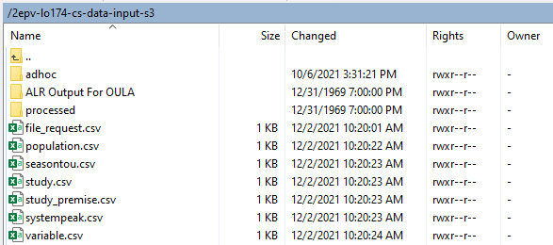
An AWS Lambda function watches the folder and executes when a trigger file lands in a subfolder under the path adhoc/incoming/

Input Files
All files are expected to be in .csv format.

Table Files
For updating tables, a separate file will be required for each table that needs to be changed. For example, if changes are intended for the study table as well as the study_premise table, two different files, study.csv, and study_premise.csv, would need to be uploaded.

File Request File
For file creation, a single file, file_request.csv, will be required. This file will contain fields for the file type (CTL or ENV), the file number(s) (Y240, Y310, Y330, or Y340), the study id, the relative month, and a SLID for the user who is making the change.

Trigger File
Additionally, a blank trigger file will need to be uploaded inside adhoc/incoming/ so that the system knows when it can begin processing the input files.
Separate trigger files are used for production and development. trigger.txt should be used for ad-hoc requests in the production environment, while trigger.csv should be used for ad-hoc requests in the development environment. In either case, the trigger file need only be a blank file. 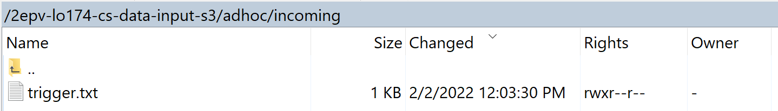
The trigger file is automatically deleted by the Lambda function once the Lambda is triggered, processing a few seconds after the file is dropped. If no request files were placed in the outer bucket but the trigger file is dropped into adhoc/incoming/, the Lambda function will still start and delete the trigger file, but then find no files to ingest and shut down.
Without a trigger, the Lambda function would start ingestion as soon as a file is uploaded, which would require files be uploaded in a correct order for referential integrity. Instead, the trigger allows files to be uploaded in any order. Once all are there and ready, the trigger file should be uploaded to signal the Lambda function to begin.

Naming Convention
Files for tables are expected to be named exactly as the table reads in ALR, with a .csv extension. The control/environment file request should be named file_request.csv. The trigger file should be named trigger.txt for production and trigger.csv for development. The system should not be case sensitive, but for convention, lowercase should be used.
- population.csv
- seasontou.csv
- study.csv
- study_premise.csv
- systempeak.csv
- variable.csv
- file_request.csv
- trigger.txt or trigger.csv

Expected File Structure
The structure of the .csv files for tables should mimic the structure of the respective table, excepting the field for updated_dt, which is handled by the system. Otherwise, there should be a column and values for every field of the table. This includes the field updated_by, where the expectation is that a SLID will be entered for the respective user. Though it needs to be repeated for each row, only one unique SLID should be entered per file.
Row-wise, there should be a separate row only for each insert/update/deletion requested. Any row not being changed should not be included. Users are expected to copy all field values (i.e. the entire row except for updated_dt) and then make changes where needed.
In general, formats for fields should exactly match the formats in the templates provided. Specifically, make sure that dates are input as dates in Excel if copied from elsewhere. The default Excel format should generally be M/D/YYYY for a plain date or M/D/YYYY h:mm:ss if a timestamp is available.
- ex.: 8/17/2021 17:05:13

The deleted_flg, and any other binary values, should be formatted as the default Excel Boolean.
- TRUE / FALSE
rltv_mo should be an integer, formatted as YYYYMM
- ex.: 202107

Inserts
To insert a new record, all fields of the new record need to be included.
The new record should have a new unique composite primary key. If the provided key values already exist in ALR, the change will be processed as an update instead of an insertion. If the ad-hoc file contains two or more records with the same primary key, an error will be reported, and the change will not take effect for those rows.

Updates
To update a record, all fields of the record need to be included, with changes made to at least one field.
The record will be updated according to its primary key.

Deletions
To delete a record, all fields of the record should be included, but the deleted_flg field should be set to TRUE.
The system does not actually remove the field from ALR, but all processes are designed to ignore any records flagged as “deleted.”

File Requests
To request control or environment files, file_requests.csv should include fields indicating the file type, a list of file numbers, the studyid, the rltv_mo, and a SLID for updated_by. For annual files, rltv_mo can be expressed as just the year integer.
- ex.: 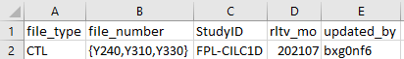

Trigger
The trigger file should be an empty .txt or .csv file.

File Request Output
The control and environment files generated by the Lambda upon request will be output in the bucket to their corresponding folders under the path ALR Output for OULA/ for both production and development.
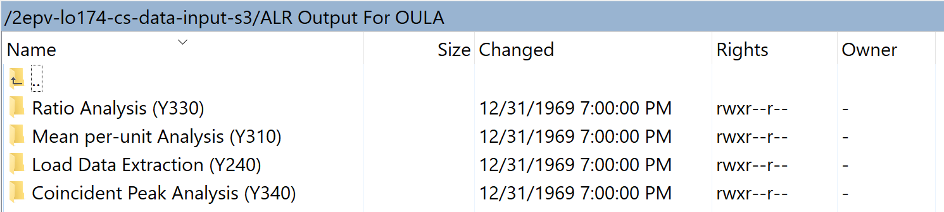
These files will be named in this pattern: <file number>_<rltv_mo/year>_<study>.<file type>
- ex.: Y330_202107_FPL-GS18.env
Files in these folders can be opened, downloaded, deleted, etc. by users. If a file already exists in a folder but is requested again, the file will be overwritten. It is expected that the regulatory team will track and maintain outputted files as needed.

Table Ad Hoc Request Example
The following records exist currently in the study_premise ALR table:
Suppose we want to:
- update the premiseid for studypoint 1.0049 to ‘1234567’
- delete the record for studypoint 1.005
To make these changes, we would upload a file titled study_premise.csv and structured as follows: 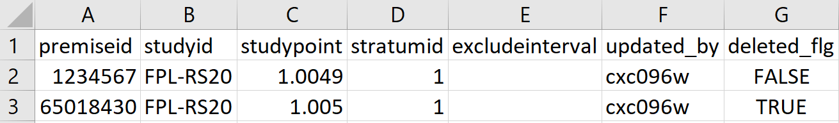

File Process Order
The adhoc_process_control table controls the processing order if multiple table ad-hoc requests are made at once, in order to ensure referential integrety. Specifically, if new studies are to be added via study.csv along with new studypoints for that study via study_premise.csv, the adhoc_process_control table ensures that the parent study table is updated before the child study_premise table.

Archive
Once files are processed successfully, the system will remove them from the main folder and move them to a separate directory, processed/ for both production and development, where they will be renamed according to their process date. Archived files will be named according to the following templates:
- <table>_<timestamp>.csv
- file_request_<timestamp>.csv
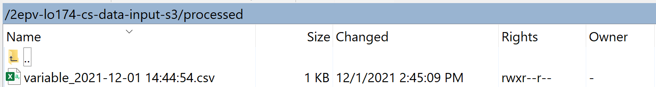Additionally, an archive table will be kept in ALR that documents changes by primary key through json format.
If a request fails, the system will remove the failing request file to a failed directory, failed/ for both production and development. The archived failing files will be named in the same pattern as the successes.

Reporting
Successfully processed ad hoc requests will be reported to a distribution list via email through AWS’s Simple Notification Service:
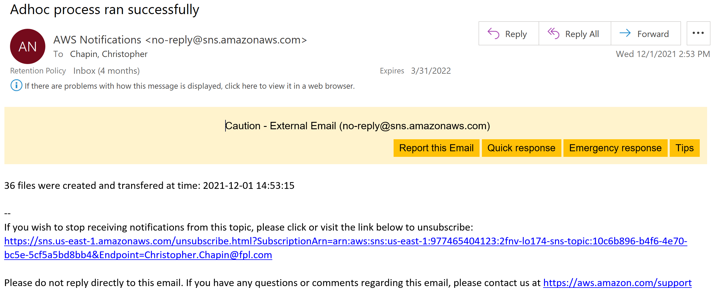
Failures are also reported through SNS, reporting the failing error to help make neccassary corrections:
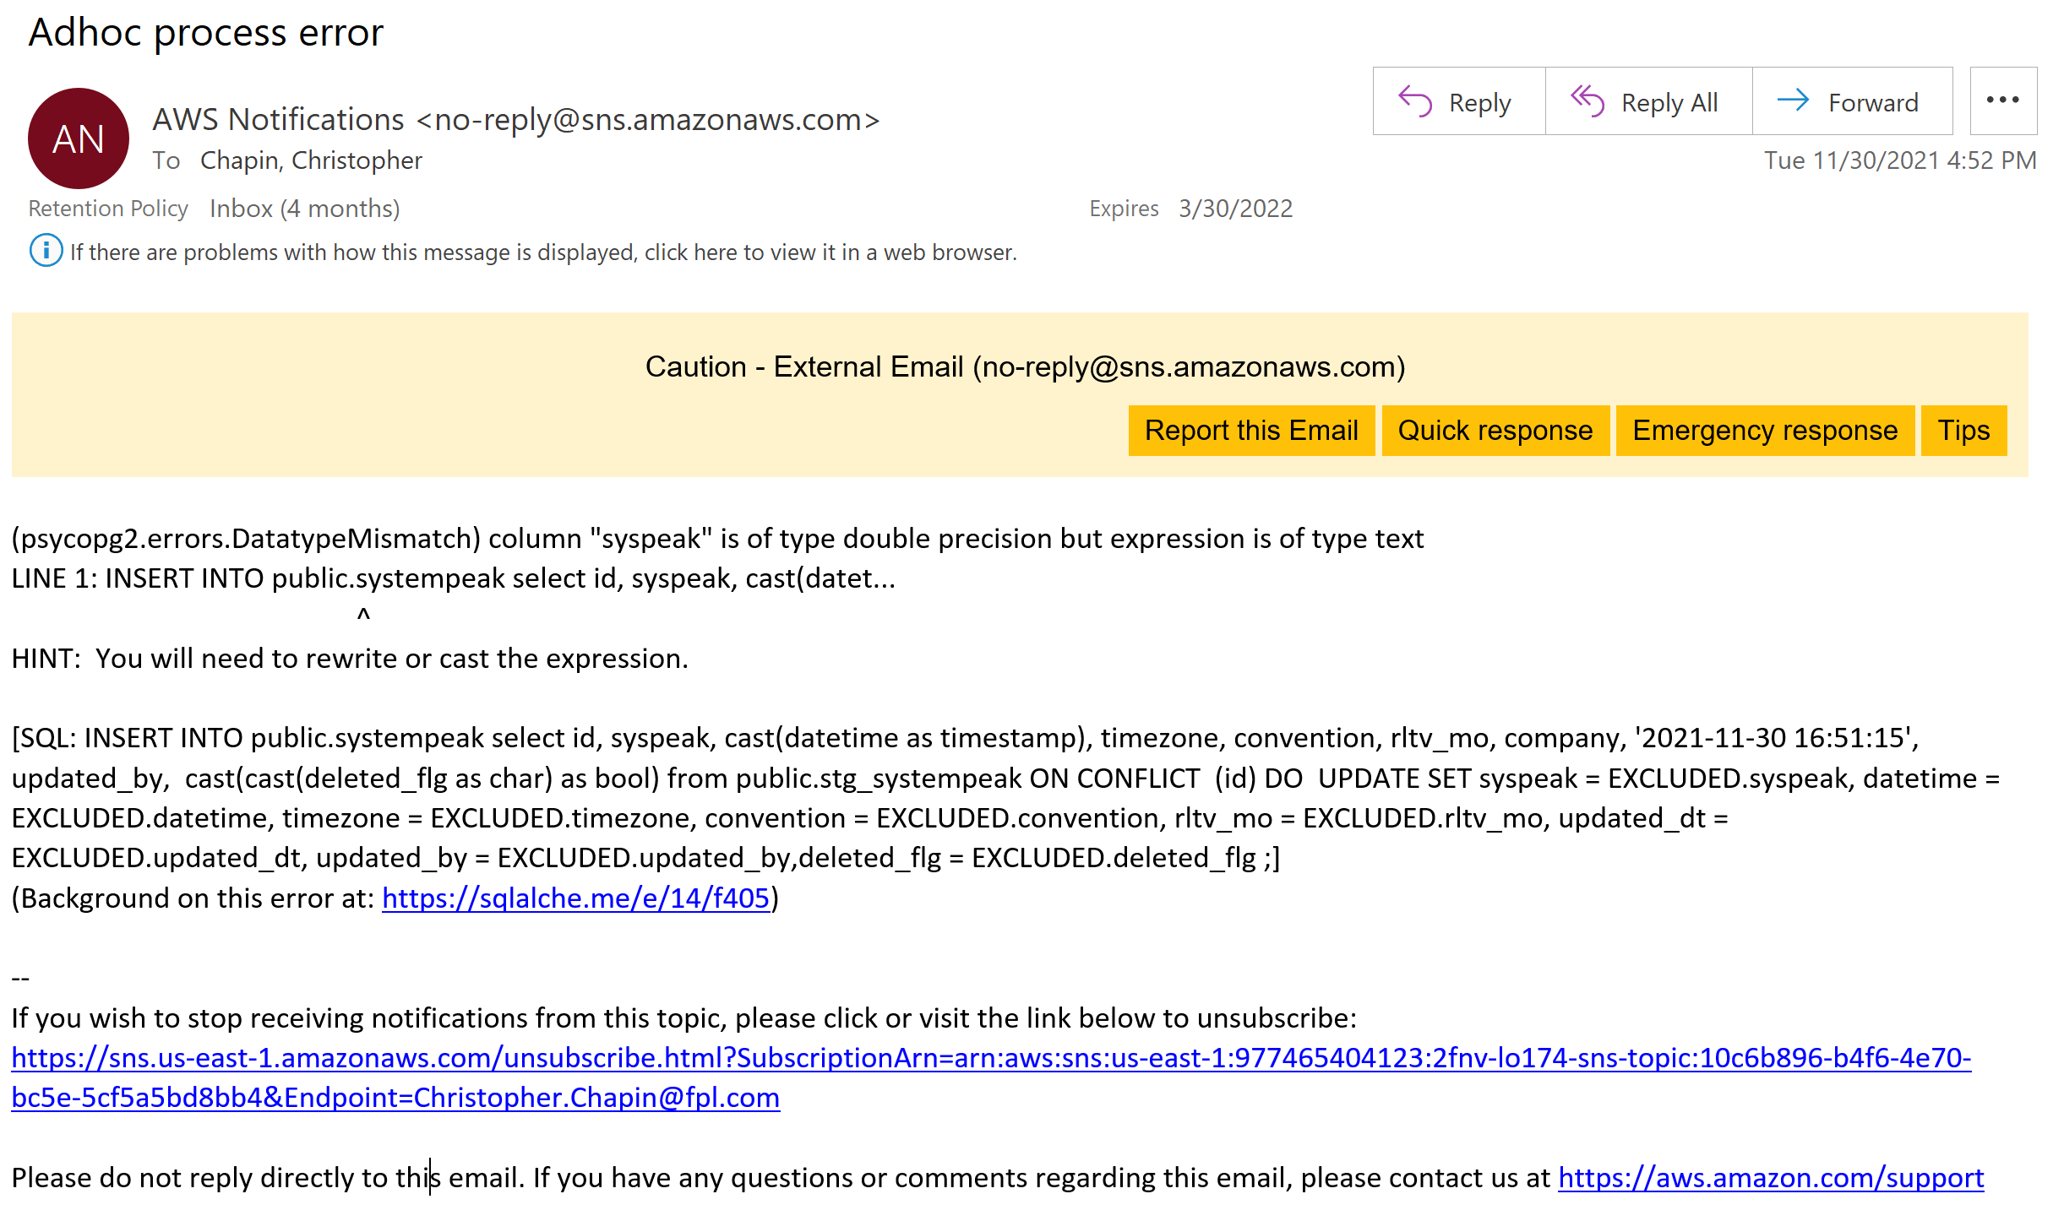
The above example shows a SQL error that tells us that the ad-hoc process failed to update systempeak because the column syspeak had at least one row that was the wrong datatype—text instead of a number (double).

A table in ALR, etl_adhoc_log , keeps track of ad-hoc requests successfully processed. This includes fields for the table name, the number of rows affected, the updated date, and a SLID for the user who made the request. File requests are also shown here, with the number_of_records field representing the number of files requested.

Long-term Archive Process
To care for database performance and costs, data no longer needed in the ALR database will be removed and archived based on a retention policy.
The archive process is scheduled via Airflow to run once per month at _____.

S3 Long-term Archive
Archived data is written to Amazon S3 Infrequently Accessed storage to save on storage costs.
Separate buckets are set up for production and development environments:
PROD | edp-lr-archive-IA-lo174-prod
DEV | edp-lr-archive-lo174-dev
These buckets can be accessed through an FTP application like FileZilla or WinSCP. Any analysis needed on archived data can be performed by connecting to a csv file directly through PowerBI or like software.
Based on the retention policies listed below, records are extracted from tables where necessary and written to .csv files in the S3 bucket by table and named accordingly:
- <table>_<rltv_mo>.csv for tables archived under the continuous policy
- <table>_<YYYY-MM>.csv for tables archived under the end-dated policy, where YYYY-MM represents the current year and month when the process runs
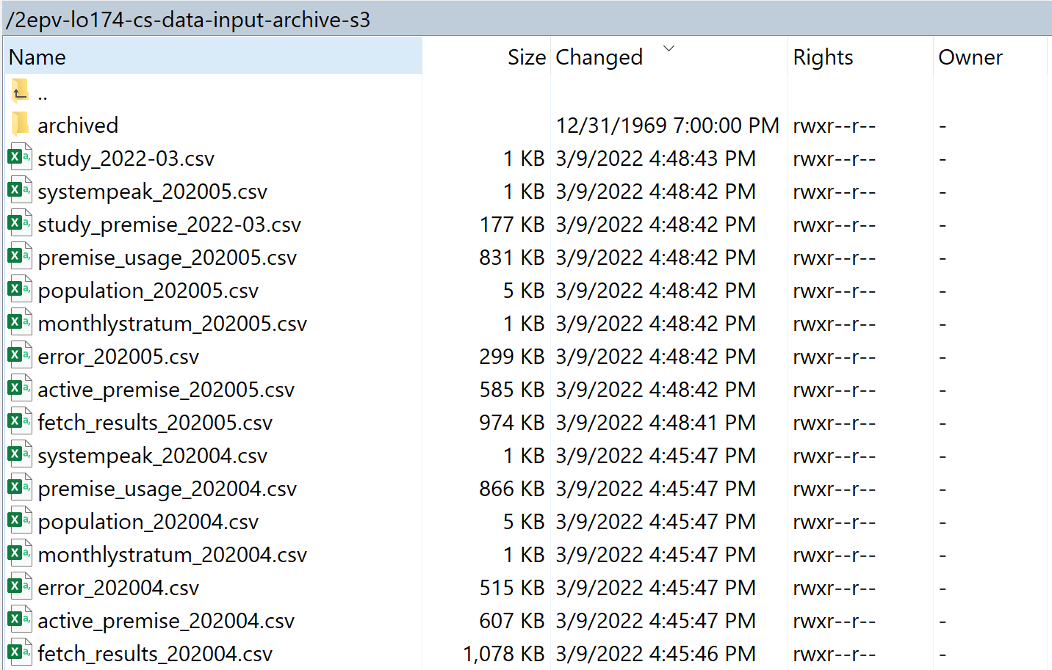
Records are also copied to a temporary backup table to protect against data loss in case the transfer to S3 fails. Once storage of the files is successful, the backup tables are dropped.

Continuous Archival Retention Policy
For all studies (continuous and end-dated) not flagged as archive exempt, records are archived when the number of months beyond the record’s rltv_mo equals the value given by STDYDATARETAIN in the variable table. For example, if STDYDATARETAIN is set to 24, all records with a rltv_mo of 202107 in a study related table will be archived in July of 2023 (rltv_mo 202307). This applies to the following tables:
- fetch_results
- premise_usage
- error
- active_premise
- monthlystratum
In this way, data for all studies are archived one rltv_mo at a time.
This process also applies to non-study-related tables that have a rltv_mo feature:
- population
- systempeak

End-Dated Archival Retention Policy
For studies with a specified end date and not flagged as archive exempt, records in the study and study_premise tables are archived when the number of months beyond the study’s end date equals or exceeds the value given by STDYDATARETAIN in the variable table. All child records for the study will already have been archived by the continuous process. For example, if STDYDATARETAIN is set to 24, records for studies with an end date of 2022-01-31 will be archived on or after 2024-01-31.
In this way, data for an end-dated study are removed from the following tables after the expiration of a study plus its retention period:
- study
- study_premise
Note that to remove a continuous study, an ad-hoc request should be made to give the study an end date. Once the study is end-dated, it will be subject to the end-dated archival process the next time the archive process runs.
If a study has multiple stratums, the end date must be repeated for each row in the study table.

Archival Exemption

run_arch_flg
Studies are subject to the archival policies as long as the run_arch_flg is set to True. To retain study related records in ALR beyond the normal retention policy, the run_arch_flg should be set to False. This would perpetually keep the record in the study table as well as all other related tables:
- study
- study_premise
- fetch_results
- premise_usage
- error
- active_premise
- monthlystratum
If the run_arch_flg had been False for a study but is changed back to True, all related records for that study will be subject to the archival process the next time the archive process runs.
If a study has multiple stratums, the run_arch_flg must be repeated for each row in the study table.

Archive Removal
Files will be permanently deleted from the archive S3 storage after they have been stored for 18 months. The number of months (18) will only be able to be changed through a change request ticket. Once files are permanently deleted from the archive, they cannot be retrieved.
fpl_reprocess.json: (monthly process)
INPUT TABLES (Source Data):
PostgreSQL (ALR Database - clr schema):
- clr.study - Active study definitions with fetch configurations
- clr.study_premise - Premise associations for studies
- clr.variable - System variables and parameters
- clr.etl_log - ETL processing log (to avoid reprocessing)
- clr.etl_backdated - Backdated processing control
Redshift (edp Database):
- ami.day - Calendar/cycle day information
- ami.pb_app_device - Power billing device configurations
- udw.bill_detail_fact - Billing detail facts
- udw.premise - Premise information with zip codes
- udw.billing_fact - Billing facts with customer data
- ami.premise_meter - Premise-meter relationships
- ami.iee_pb_duration_read_fact - IEE power billing reads
- ami.pb_tms_duration_read_fact - TMS power billing reads
- ami.pb_duration_read_fact - Standard power billing reads
- ami.pb_app_duration_read_fact - APP power billing reads
- ami.pb_mv90_duration_read_fact - MV90 power billing reads
- ami.meter_duration_read_fact - Meter reading facts
Final Output Tables:
These temporary dataframes ultimately feed into the main ALR tables:
- fetch_results - Monthly meter/channel level data
- premise_usage - Monthly premise/account/bill aggregated data
- active_premise - Active premise tracking with switching logic
- error - Validation and processing error logs

